Key Vocabulary - Geography
Continent | A continent is a large solid area of land. Earth has seven continents. In order from largest to smallest, they are Asia, Africa, North America, South America, Antarctica, Europe, and Australia
Ocean | An ocean is a huge body of salt water.
Equator | The Equator is an imaginary circle around Earth. It divides Earth into two equal parts: the Northern Hemisphere and the Southern Hemisphere. It runs east and west halfway between the North and South poles.
Physical Features | Physical features are natural features, such as mountains, rivers, deserts and oceans.
Human Features | A human feature is something that is built by humans and would not have existed in nature without humans.
Walk on the Wild Side

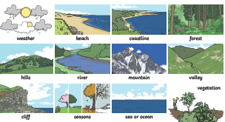

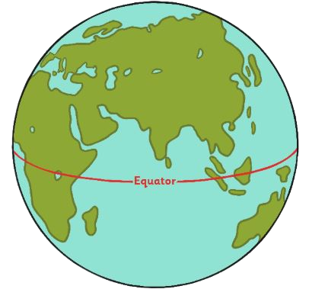

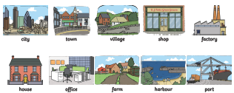
Key Vocabulary - Science
Amphibians | Amphibians live in the water as babies and on land as they grow older. They have smooth, slimy skin.
Birds | All birds have a beak, two legs, feathers and wings.
Fish | Fish live and breathe under water. They have scaly skin, fins to help them swim and they breathe through gills.
Mammals | Mammals are animals that breathe air, grow hair or fur and feed on their mother’s milk as a baby.
Reptiles | All reptiles breathe air. They have scales on their skin.
Carnivore | Animals that mostly eat other animals (meat) are carnivores.
Herbivore | Animals that only eat plants are herbivores.
Omnivore | Animals that eat both plants and other animals are omnivores.
Key Vocabulary - Science

life processes | These are the things that all living things do. They move, breathe, sense, grow, make babies, get rid of waste and get their energy from food.
living | Things that are living have all the life processes.
non-living | Things that are non-living (dead) were once living. They did have all the life processes but don’t now.
never lived | Things made out of metal, plastic or rock were never living. They never had life processes.
food chain | A food chain shows how each animal gets its food. Food chains are one of the ways that living things depend on each other to stay alive.
food sources | This is the place a living thing’s food comes from.
habitat | A habitat is the natural place something lives. A habitat provides living things with everything that they need to survive such as food, shelter and water.
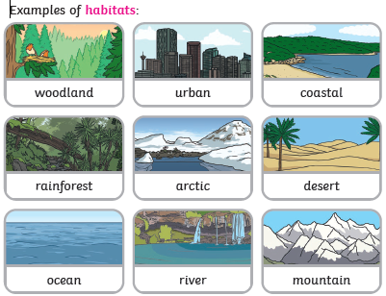

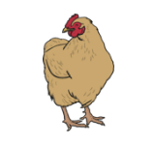  Living | Non-living | Never lived  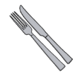

Recommended Reading
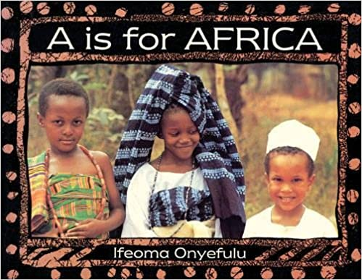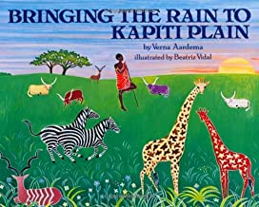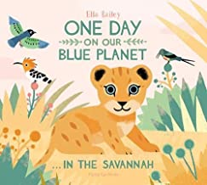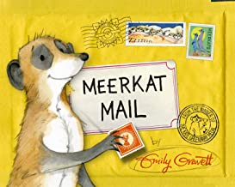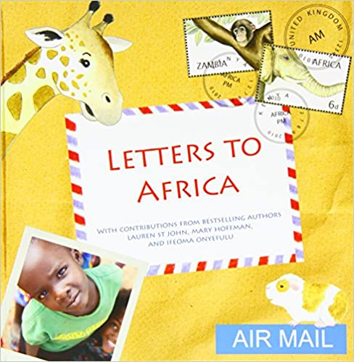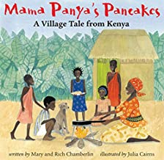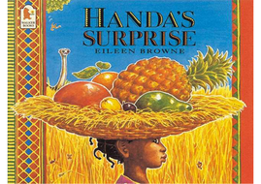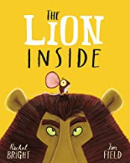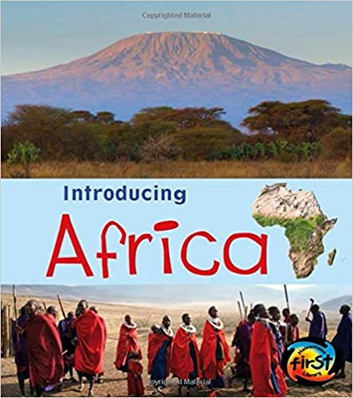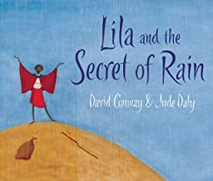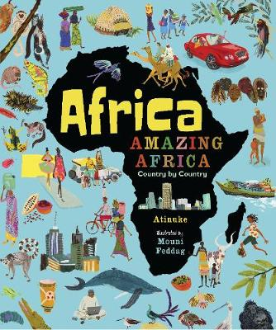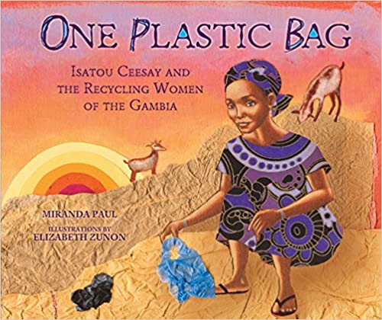

The Big Five

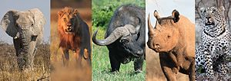

Key Knowledge
- Know the names of and locate the seven continents of the world
- Know the names of and locate the five oceans of the world
- Know the main differences between a place in England and that of a small place in a non-European country
- Know and identify physical features: mountain, lake, island, valley, river, cliff, forest and beach
- Know and identify human features: city, town, village, factory, farm, house, office, port, harbour and shop
- Know where the equator, North Pole and South Pole are on a globe
- Know how to classify things by living, dead (non-living) or never lived
- Know how a specific habitat provides for the basic needs of things living there (plants and animals)
- Know how to match living things to their habitat
- Know and name some different sources of food for animals
- Know about and explain a simple food chain
- Know the basic stages in a life cycle for animals, (including humans)
- Know how to classify a range of animals by amphibian, reptile, mammal, fish and birds
- Know and classify animals by what they eat (carnivore, herbivore and omnivore)
- Know how to sort by living and non-living things

Key questions and activities.
Geography
Use a globe, a map or look online to find the continents and oceans.
Do you know where England is on a map? Can you find Africa? Look at pictures of England and Africa landscapes. Are they similar or different?
Think about your day. What activities do you do? Do think your day is the same or different to a child in Africa. Make a visual timetable of your day. What time do you wake up? What do you do before school? Make a timetable of a normal day at school. Can you find out about a day in the life of a child in Kenya?
Look at the human and physical features in Bussage. How many different features can you find? Can you find out about human and physical features in Kenya?
Look at your house and other houses. Draw a picture of your house and add labels. Can you name the different parts of the house and the materials? Look at pictures of houses in Kenya. Are the houses the same or different to your house?
Science
Go outside and name anything you can find that is living and non-living. Draw and label pictures. Can you find anything that has never lived?
Have you got a pet? If not, do you know anyone with a pet? What does the animal look like? How do you look after it? What does it need to survive?
Can you sort the animals into the five main groups?
What do animals eat? Can you find out about carnivores, herbivores and omnivores?
Can you label the main body parts of animals?
Do you know how animals grow from babies into adults? What changes happen? Choose an animal and find out how it grows and changes.
Where do animals live? Do they all live in the same place? Look at the different habitats. Be a detective and look outside. How many different mini-beasts can you find? What is special about their habitat?
Can you find out about the Big Five animals in Africa? How are the animals the same and how are they different? Where do the Big Five animals live and what do they eat?
Art/DT
Have you ever seen a beautiful sunset? Can you draw or paint a sunset and then add silhouettes of African animals and trees?
Can you draw different fruits and print with them?
Do you know that in Africa they use special patterns to make designs? They use the designs to make Kente cloths. See if you can find out about Kente cloths and then draw your own design.
Can you make a collage of an African animal in its habitat?
Music
Have a go at making long and short sounds using different objects. Can you find out the names of some African instruments? Maybe you could make your own drum (djembe) out of recycled materials. Practise some rhythms by watching African drumming on YouTube https://www.youtube.com/watch?v=q5U8md4rZS8

