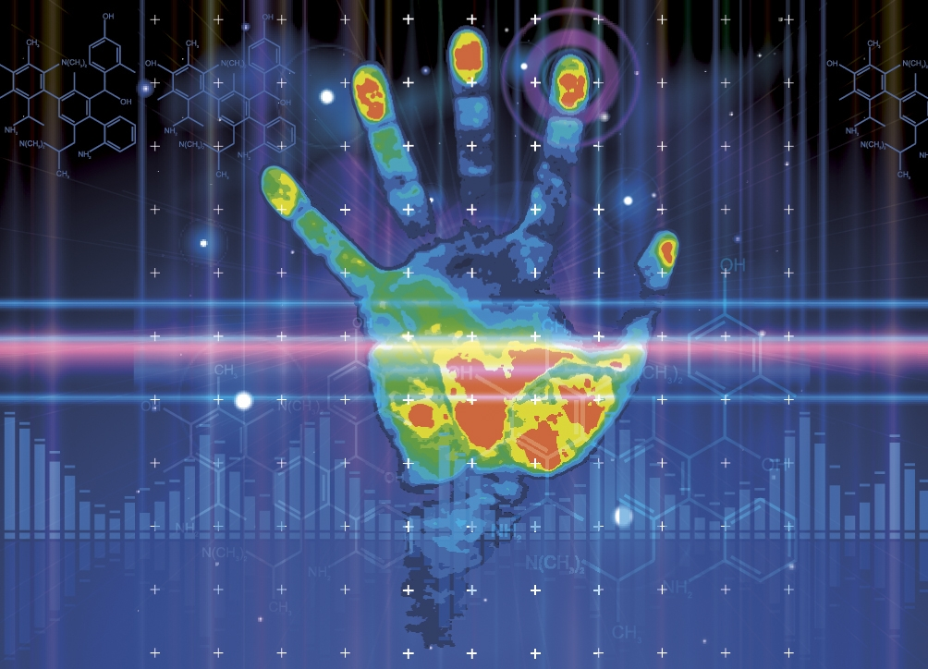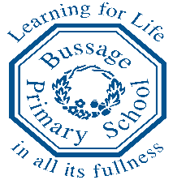 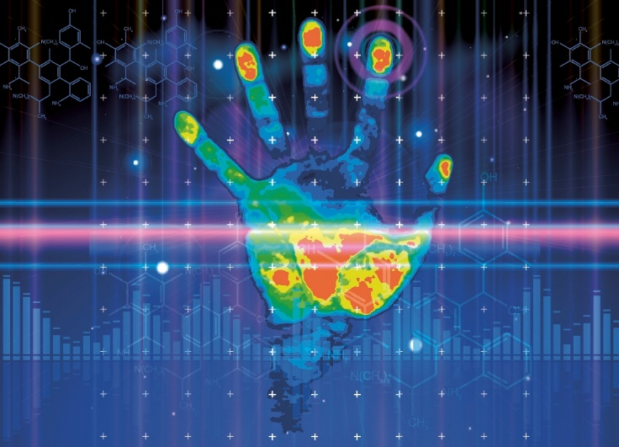

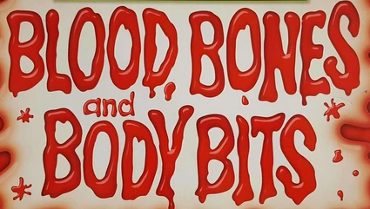

**D&T**

Design and make body boxes –replicas of the internal of an adult torso.

* Join textiles with a combination of stitching techniques
* Evaluate the design of products so as to suggest improvements to the user experience.

Design their own board game based on being healthy

* Design with the user in mind, motivated by the service a product will offer

Food- Know the basic principles of a healthy and varied diet to prepare dishes. Know where food comes from.

**English**

Persuasive leaflet/report on ‘Know how to lead a healthy life’

Explanation text - Know the digestive or circulatory system work (science and music link)

Instructions – Create a Healthy lifestyle board game

Narrative- Frankenstein by Mary Shelley

**Numeracy**

* Multiplication and division
* Fractions, decimals and percentages
* Know properties of 2D and 3D Shape
* Problem Solving using reasoning questions

**Science**

Know that humans have skeletons and muscles for support, protection and movement

Know how the Digestive and Circulatory systems works.

(How are nutrients and blood transported within the human body?)

Know the functions of the heart, blood vessels and blood.

Know the different types of teeth in humans and their simple functions

Know changes as humans develop from birth to old age

Know how we see and hear.

**Music**

Know how to perform with controlled breathing-Perform solos or as part of an ensemble- Beat box/rap

Sing expressively and in tune.

Sing or play from memory with confidence.

Know how to create rhythmic patterns with an awareness of timbre and duration.

Know and understand simple time signatures.

Know how to use digital technologies to compose, edit and refine pieces of music.

**PE**

Dance - Plan to perform with high energy, slow grace or other themes and maintain this throughout a piece.

Gymnastics using low balance equipment

Invasion games -Hockey

**MFL – French**

* Know names for parts of the body
* Know names for different foods
* Express opinions about different sporting and leisure activities

**Computing**

**Programming**

Use logical thinking, imagination and creativity to extend a program

**Handling Data**

* Choose an appropriate tool to collect, present and record data

**Multimedia**

* Use text, photo, sound and video editing tools to refine my work

**e-Safety**

* Know that anything I post online can be seen, used and may affect others.
* Discuss the importance of choosing an age-appropriate website or game
* Explain why I need to protect myself and my friends.

**RE**

What does it mean to be a Muslim in Britain today?

What do Christians believe Jesus did to ‘save’ people?

**PSHE**

* Health and Well being
* Healthy lifestyles
* Being my best

SCARF scheme -Includes keeping healthy/growth mindset/goal setting and achievement

**Art**

* Take inspiration from the greats: Picasso

Create an original piece that shows the range of influence and style.

* Giacometti

Sculpture – show lifelike qualities and real life proportions.

Use frameworks to provide stability and form (such as wire)

* Digital media – use of video and still images of body form to help in creation of sculptures