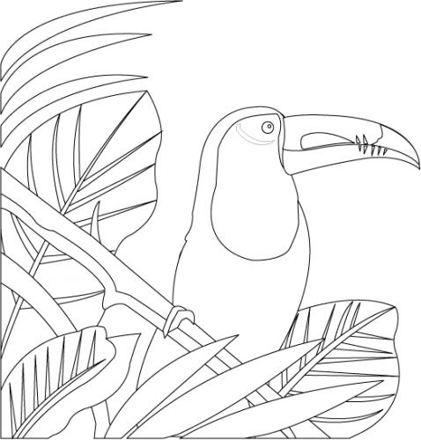

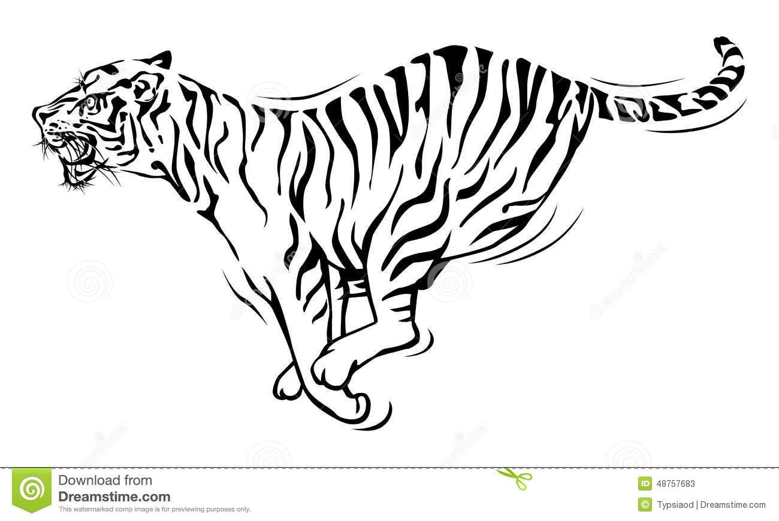

Jungle Fever

Year 6

Autumn Term 2018

**French**

*Revision of previous year’s themes

*Parts of the body

*Animals

**PE**

*Gymnastics : Balances

*Dance: Rainforest dance

*Games: Tag Rugby

**Computing**

**Programming**

*Understand that efficient algorithms can be used to solve problems and to plan for specific outcomes.

*Design and write programs that accomplish specific goals.

*Use sequence, selection and repetition in programs.

*Use logical reasoning to detect and correct errors in algorithms and programs.

**PSHE**

*Healthy relationships (SCARF)

*Living in the wider world – caring for the environment (SCARF)

* Facts4life

*Mindfulness and peer massage

**RE**

*Creation & science – conflict or complimentary?

*Christians and how to live: ‘What would Jesus do?’

**Maths**

*Place value – reading & writing large numbers, ordering, rounding, decimalsand negative numbers

*Fractions, decimals and percentages.

*Four rules of number – mental and written calculation strategies

*Statistics - Data handling & mean

**DT**

*Create objects that employ a seam allowance.

*Join textiles with a combination of stitching techniques

*Use the qualities of materials to create suitable visual and tactile effects in the decoration of textiles (such as a soft decoration for comfort on a cushion).

**Geography**

*Name and locate the countries of North and South America and identify their main physical and human characteristics.

*Identify and describe the geographical significance of latitude, longitude, Equator, Northern Hemisphere, Southern Hemisphere, the Tropics of Cancer and Capricorn, Arctic and Antarctic Circle, and time zones (including day and night).

**\*Physical geography**, including: climate zones, biomes and vegetation belts, rivers,

*Use different types of fieldwork sampling (random and systematic) to observe, measure and record the human and physical features in the local area. Record the results in a range of ways.

*Describe how locations around the world are changing and explain some of the reasons for change.

*Identify and describe how the physical features affect the human activity within a location.

Collect and analyse statistics and other information in order to draw clear conclusions about locations.

**Music**

*Perform with controlled breathing. Perform solos or as part of an ensemble. Sing expressively and in tune. Sing or play from memory with confidence.

*Create rhythmic patterns with an awareness of timbre and duration.

*Use and understand simple time signatures.

*Use digital technologies to compose, edit and refine pieces of music.

**Art**

*Give details (including own sketches) about the style of some notable artists, artisans and designers.

*Create original pieces that show a range of influences and styles.

*Choose a style of drawing suitable for the work (e.g. realistic or impressionistic).

*Apply knowledge and ideas from the great artists. (Henri Rousseau)

*Mix textures (rough and smooth, plain and patterned).

Combine visual and tactile qualities

**English**

*Explanation text – life cycle of a plant

*Non-chronological report – Rainforest animal

*Narrative – Story settings

*Balanced discussion/debate - deforestation

**Science**

*Identify and describe the functions of different parts of flowering plants: roots, stem, leaves and flowers.8Investigate the way in which water is transported within plants

*Explore the requirements of plants for life and growth (air, light, water, nutrients from soil, and room to grow) and how they vary from plant to plant.

*Explore the role of flowers in the life cycle of flowering plants, including pollination, seed formation and seed dispersal.

*Describe the life processes of plants and animals.

*Relate knowledge of plants to studies of all living things.

*Explain the classification of living things into broad groups according to common, observable differences, including plants, animals and micro-organisms.

*Relate knowledge of plants to studies of evolution and inheritance.

Variation leading to competition which can drive adaptation and changes in the environment that leave some species less well adapted to complete successfully and reproduce.