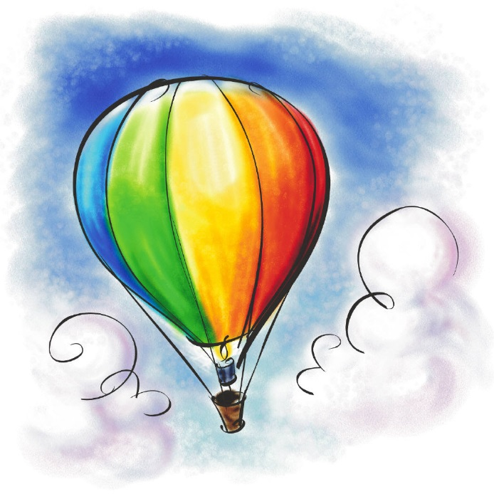

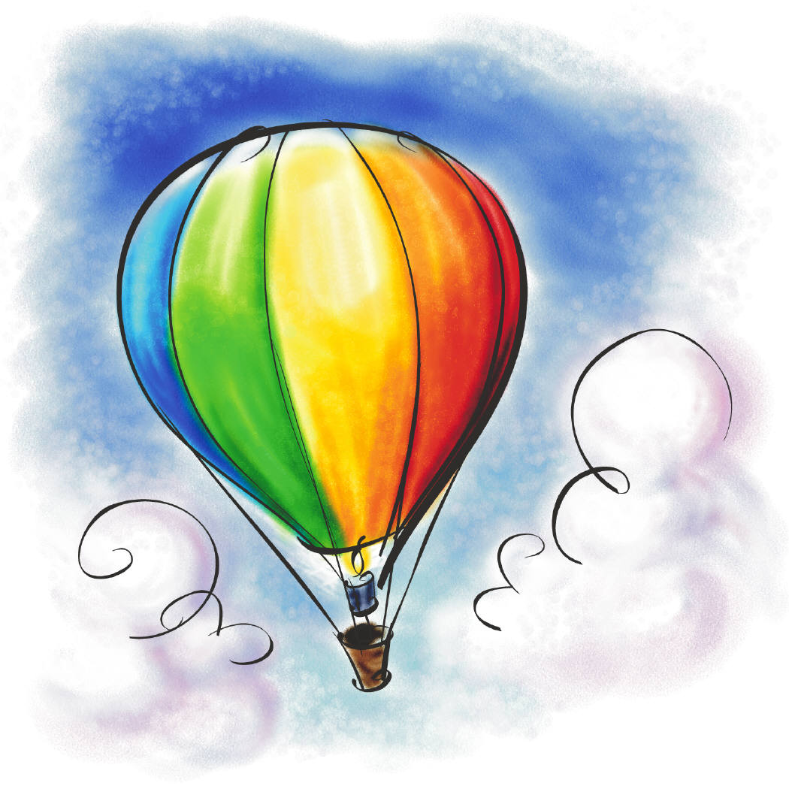

**SCIENCE**

* **Habitats- identifying in the locality and around the world**
* **Adaption of animals to suit their environment**
* **Environmental threats – focussing on the Polar regions.**
* **Analysing data**
* **Classification of animals**

**GEOGRAPHY**

* **Identify Continents/Oceans on a world map**
* **Name European Countries and research one in detail**
* **Identify features of North America, Australia and Polar Regions**
* **A local fieldwork study of Bussage- reading and drawing maps. Identifying symbols/keys/grid references.**

**HISTORY**

* **Make a timeline of different world explorers.**
* **Discover how Bussage has changed over time.**

**LITERACY**

* **Captions- Postcards**
* **Letter/diary/recount- Phileas Fogg’s journey**
* **Research- Antarctica**
* **Non-Chronological reports- Arctic and Antarctic animals**
* **Oral Presentations of Non-Chronological reports.**
* **Narrative- Aboriginal dreamtime** **stories.**

**PE**

**Real PE - focusing on Balance, coordination and creative skills.**

**ART**

**Aboriginal Art**

**Pencil sketches**

**Detailed observation from life**

**DT**

**European Food festival- tasting food from Europe**

**80 Days Around The World**

**MATHS**

* **Place Value**
* **Addition / Subtraction**
* **Multiplication / Division**
* **Times table and division recall**

**FRENCH**

**Numbers, Greetings, personal details**

**R.E**

**How and why do people try to make the World a better place?**

**What is the Trinity and why is it important to Christians?**

**Music**

**Music from around the World**

**Sing and perform folk songs from other countries.**