ADDITION

STATUTORY EXPECTATIONS Rapid Recall/Mental Calculations Non-statutory guidance
YR | Count … from 1-20 … and say which no. is 1 more than a given no. Using quantities objects, + two U nos and count on to find the answer. [Expected] Estimate no. of objects; check quantities by counting up to 20. [Exceeding] | Practical or recorded using ICT.  Hannah … listed how many girls and how many boys were outside. [She] was able to say that “There are 5 girls and 4 boys. That’s 9 altogether”.  When playing in the shop Christopher used his shopping list to add 2 amounts. He said “the beans are 5 pence and the bananas are 3 pence, altogether that is 8 pence.”  [EYFS Profile exemplifications, STA] |  |  |  |  |  | Pictures/Objects  Might be recorded as:  2 + 3 = 5  I eat 2 cakes and my friend eats 3.  How many cakes did we eat altogether?   |  |  |  |  |  |  |  |  |  | Symbolic  8 people are on the bus. 5 more get on at the next stop.  How many people are on the bus now  [Might be recorded as: 8 + 5 = 13]
Y1 | Add (and subtract) one-digit and two-digit numbers to 20 (9 + 9, 18 - 9), including zero  Read/write/interpret statements involving addition (+), subtraction (-) and equals (=) signs. | Pupils use concrete objects and pictorial representations  (eg place value counters, Dienes)  Problems should include terms: put together, add, altogether, total, take away, distance between, more than and less than, so pupils develop concept of +/- and use operations flexibly. |  |  | Practical/recorded using ICT  Pictures/Symbolic (see above) |  |  |  |  |  | Visual  (modelled using bead strings)  13 + 5 = 18  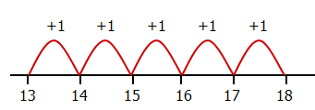 |  |  |  | Visual (efficient jumps)  13 + 5 = 18  [jumps may be in 1s]  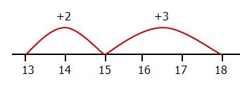 |  |  |  |  |  |  |  |  | Use known facts/partitioning  8 + 5 + 13  8 + 2 = 10  10 + 3 = 13 | Represent/use number bonds (and related subtraction facts) within 20.  Missing number problems (eg 16 = ? + 9) | Memorise/reason with bonds to 10/20 in several forms (eg 9 + 7 = 16; 16 - 7 = 9; 7 = 16 - 9). Pupils should realise the effect of adding or subtracting zero - establishes +/- as related operations.  Pupils combine and increase numbers, counting forwards and backwards.
Y2 | TU + U  TU + tens  TU + TU  U + U + U  [Show addition of two numbers can be done in any order.] | Recognise/use inverse relationship between +/- and use to check calcs and missing number problems.  Pupils use concrete objects, pictorial representations and mental strategies.  (eg place value counters, Dienes) | Practical/visual images  58 + 30 = 88  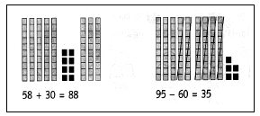 |  |  |  |  | Visual (efficient jumps)  35 + 47= 82  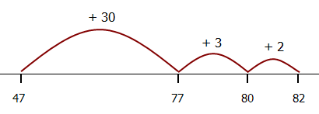  [Also jumps can be in 10s and 1s] |  |  |  |  | No number line  35 + 47 = 82  47 + 30 = 77  77 + 3 = 80  80 + 2 = 82 |  |  |  | Partitioning  35 + 47 = 82  40 + 30 = 70  7 + 5 = 12 |  |  |  |  |  | Recording addition in columns supports place value and prepares for formal written methods with larger numbers.  47 + 35 = 82  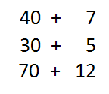 |  | Recall and use addition facts to 20 fluently.  Derive and use related facts up to 100.  Solve problems by applying increasing knowledge of mental methods. | Pupils extend understanding of the language of + to include sum.  Practise + to 20 to derive facts such as using 3 + 7 = 10 to calculate 30 + 70 = 100, 100 - 70 = 30 and 70 = 100 - 30. Check calcs, including by adding numbers in a different order to check +.  Establishes commutativity and associativity of addition.
Y3 | Use formal written methods of columnar addition.  TU + TU  HTU + TU  HTU + HTU | Number line 57 + 285 = 342  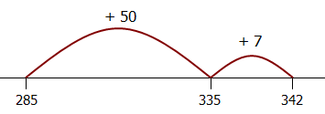 |  | No number line  57 + 285 = 342  285 + 50 = 335  335 + 7 = 342 |  |  |  |  | 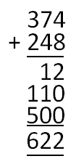  Expanded  vertical |  |  |  |  | 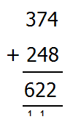  Compact vertical |  |  |  |  | Estimate answers and use inverse to check. |  |  |  |  |  | HTU + U; HTU + tens  HTU + hundreds  Use number facts and place value to solve problems.  For mental calcs with TU nos, answers could be >100.
Y4 | Use formal written methods of columnar addition.  HTU + HTU  ThHTU + HTU  ThHTU + ThHTU | Estimate and use inverse operations to check answers to a calculation.  Estimate, compare and calculate different measures, including money in pounds and pence. | 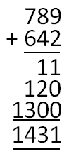  Expanded vertical  789 + 642 = 1431 |  |  |  |  |  |  | 789 + 642 = 1431  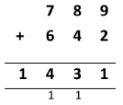 |  | 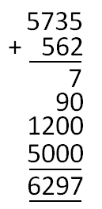  5735 + 562 = 6297 |  |  |  | 5735 + 562 = 6297  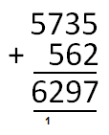 |  |  |  |  |  | Solve addition two-step problems in contexts, deciding which operations and methods to use & why.  Solve simple measure and money problems involving fractions and decimals to 2dp |  |  | Pupils continue to practise both mental methods and columnar addition and subtraction with increasingly large numbers to aid fluency. | Pupils build on their understanding of place value and decimal notation to record metric measures, including money.
Y5 | Add whole numbers >4 digits, including using formal written methods (columnar addition).  Decimals up to 2dp  (eg 72.5 + 45.7) | Use rounding to check answers to calculations and determine, in the context of a problem, levels of accuracy.  Solve addition multi-step problems in contexts, deciding which operations and methods to use and why. |  |  |  | Solve problems involving number up to 3dp.  Solve problems involving converting between units of time. [Measurement]  Use all four operations to solve problems involving measure [eg length, mass, volume, money] using decimal notation including scaling. [Measurement] |  |  |  |  |  |  |  |  |  |  | Compact vertical  23.70  + 48.56  72.26  1 1 |  |  |  | Pupils practise adding decimals, including a mix of whole numbers and decimals, decimals with different numbers of decimal places, and complements of 1. |  |  |  | Add numbers mentally with increasingly large numbers  (eg 12462 + 2300 = 14762).  Pupils mentally add tenths, and one-digit whole numbers and tenths. | They extend their knowledge of fractions to thousandths and connect to decimals and measures.  Pupils should go beyond the measurement and money models of decimals (eg by solving puzzles.
Y6 | Solve multi-step problems in contexts, deciding which operations/methods to use and why.  Decimals up to 3dp (Context: Measures) | Use estimation to check answers to calculations and determine, in the context of a problem, an appropriate degree of accuracy. | Use knowledge of the order of operations to carry out calculations involving subtraction. |  |  |  | Solve problems which require answers to be rounded to specified degrees of accuracy. [Fractions]  Solve problems involving the calculation and conversion of units of measure, using decimal notation to 3dp where appropriate. [Measurement] |  |  |  |  |  |  |  |  |  |  |  |  | Compact vertical  3.243  + 18.070  21.313  1 1 |  |  |  |  | Perform mental calculations, including with mixed operations and large numbers.  Using the number line, pupils add positive and negative integers for measures such as temperature. | Pupils develop skills of rounding/estimating to predict/check order of magnitude of ans to decimal calcs. Includes rounding answers to a degree of accuracy & checking reasonableness.

SUBTRACTION

STATUTORY EXPECTATIONS Rapid Recall/Mental Calculations Non-statutory guidance
YR | Count … from 1-20 … and say which no. is 1 less than a given no. Using quantities objects, subtract two U nos and count back to find the answer. [Expected] Estimate no. of objects; check quantities by counting up to 20. [Exceeding] | Practical or recorded using ICT.  Chloe was playing in the maths area. “I need three more” she said as she added some cubes to the circle. She then realised she had more than her friend. “Oh, I have too many”. She removed one. “Now we have the same”.  During a game of skittles outdoors Joseph knocked three numbered skittles down. He was able to calculate his score in his head.  [EYFS Profile exemplifications, STA] |  |  |  |  |  |  |  | Pictures/Objects  I have five cakes. I eat two of them. How many do I have left?  Might be recorded as: 5 – 2 = 3 |  |  |  |  |  |  |  |  |  |  |  | Symbolic  Mum baked 9 biscuits. I ate 5. How many were left?  [Might be recorded as: 9 – 5 = 4]
Y1 | Subtract (and add) one-digit and two-digit numbers to 20 (9 + 9, 18 - 9), including zero  Read/write/interpret statements involving addition (+), subtraction (-) and equals (=) signs | Practical or recorded  using ICT.  Pupils use concrete objects and pictorial representations  (eg place value counters, Dienes) | Taking away – jumps of 1  (modelled using bead strings)  13 – 5 =8  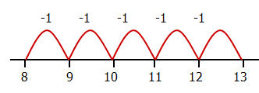 |  |  |  |  |  |  |  |  | Taking away  (efficient jumps) 13 – 5 = 8  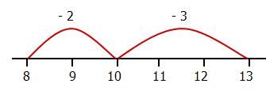  No number line:  13 – 3 = 10  10 – 2 = 8 |  |  |  |  |  |  | Counting on – jumps of 1  (modelled using bead strings)  11 – 8 = 3  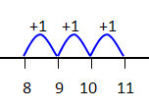 |  |  |  |  |  |  |  | Counting on (efficient jumps)  With, or without, number line  8 + 2 = 10  10 + 1 = 11 |  | Represent/use number bonds and related subtraction facts within 20.  Problems should include terms: put together, add, altogether, total, take away, distance between, more than and less than, so pupils develop concept of +/- and use operations flexibly.  Missing number problems (eg 7 = ? – 9) | Memorise/reason with bonds to 10/20 in several forms (eg 9 + 7 = 16; 16 - 7 = 9; 7 = 16 - 9). Pupils should realise the effect of adding or subtracting zero - establishes +/- as related operations.  Pupils combine and increase numbers, counting forwards and backwards.
Y2 | TU - U  TU - tens  TU - TU  [Show subtraction of two numbers cannot be done in any order.] | Recognise/use relationship betw. +/- to check calcs and missing number problems.  Pupils use concrete objects and pictorial representations and mental strategies (eg place value counters, Dienes) |  | Practical/visual images  95 - 60 = 35 |  |  | Taking away 84 - 36 = 48  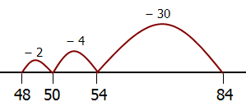  [Also jumps can be in 10s/1s] |  |  |  |  |  |  | Taking away  (no number line)  84 - 36 = 48  84 - 30 = 54  54 - 4 = 50  50 - 2 = 48 |  |  |  |  |  | Counting on 84 - 48 = 36  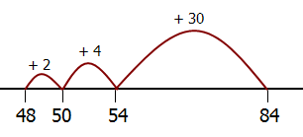  [Also jumps can be in 10s/1s] |  |  |  |  | Recording subtraction in columns supports place value and prepares for formal written methods with larger numbers.  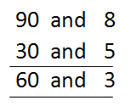  98 - 35 = 63 |  |  |  | Recall and use subtraction facts to 20 fluently.  Derive and use related facts up to 100.  Solve problems by applying increasing knowledge of mental methods. | Pupils extend understanding of the language of subtraction to include difference.  Practise subtraction to 20 to derive facts such as using 3 + 7 = 10, 10 - 7 = 3 and 7 = 10 - 3 to calculate 30 + 70 = 100, 100 - 70 = 30 and 70 = 100 - 30. Check calculations, including by adding to check subtraction.
Y3 | Use formal written methods of columnar addition  TU - TU  HTU - TU  HTU - HTU | 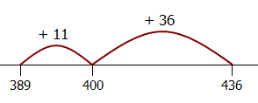  Counting on 436 - 389 = 47 |  |  |  | Taking away (no number line)  326 - 178 = 148  326 - 100 = 226  226 - 70 = 156  156 - 6 = 150  150 - 2 = 148 |  |  |  |  |  |  | 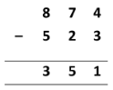  874 - 523 = 351  (no decomposition |  |  |  |  | Decomposition  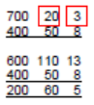  723 - 458 = 265 |  |  |  |  | Decomposition  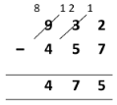  932 - 457 = 475 |  |  |  |  | Estimate answers and use inverse to check. | HTU - U  HTU - tens  HTU – hundreds  Use number facts and place value to solve problems.
Y4 | Use formal written methods of columnar subtraction.  HTU - HTU  ThHTU - TU  ThHTU - HTU  ThHTU - ThHTU | 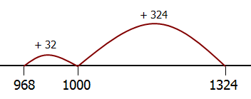  Counting on 1324 - 968 = 356 |  |  |  |  |  | Decomposition: 1374 - 968 = 406  1000 300 70 4  900 60 8  1300 60 14  900 60 8  400 0 6 |  |  |  |  |  |  |  | Decomposition  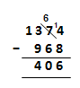  1374 - 968 = 406 |  |  |  |  | Solve subtraction two-step problems in contexts, deciding which operations and methods to use and why.  Solve simple measure and money problems involving fractions and decimals to 2dp. |  |  |  |  | Estimate and use inverse operations to check.  Estimate, compare and calculate different measures, including money in pounds and pence. |  |  | Pupils continue to practise both mental methods and columnar addition and subtraction with increasingly large numbers to aid fluency. | Pupils build on their understanding of place value and decimal notation to record metric measures, including money.
Y5 | Subtract whole numbers >4 digits, including using formal methods (columnar subtraction).  Decimals up to 2dp  (eg 72.5 - 45.7) | Use rounding to check answers to calculations and determine, in the context of a problem, levels of accuracy.  Solve multi-step problems in contexts, deciding which operations/methods to use and why. |  |  | Solve problems involving number up to 3dp. [Fractions]  Solve problems involving converting betw. units of time.  [Measurement]  Solve problems involving measure [eg length, mass, volume, money] using decimal notation including scaling.  [Measurement] |  |  |  |  |  | 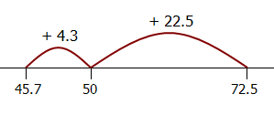  Counting on  72.5 – 45.7 = 26.8 |  |  |  | Taking away  (no number line)  72.5 – 45.7  72.5 – 40 = 32.5  32.5 – 5 = 27.5  27.5 – 0.7 = 26.8 |  |  |  |  |  | Decomposition  72.5 - 45.7 = 26.8  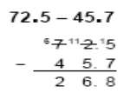 |  |  | Pupils practise subtracting decimals, including a mix of whole numbers and decimals, decimals with different numbers of decimal places, and complements of 1. |  |  |  |  | Subtract numbers mentally with increasingly large numbers  (eg 12462 - 2300 = 10162).  Pupils mentally subtract tenths, and one-digit whole numbers and tenths. | They extend their knowledge of fractions to thousandths and connect to decimals and measures.  Pupils should go beyond the measurement and money models of decimals (eg by solving puzzles.
Y6 | Solve multi-step problems in contexts, deciding which operations/methods to use and why. Decimals up to 3dp (Context: Measures) | Use knowledge of the order of operations to carry out  calculations involving subtraction.  Use estimation to check answers to calculations and  determine, in the context of a problem, an appropriate  degree of accuracy. |  |  |  |  |  |  | Solve problems which require answers to be rounded to specified degrees of accuracy. [Fractions]  Solve problems involving the calculation and conversion of units of measure, using decimal notation to 3dp where appropriate. [Measurement] |  |  |  |  |  |  |  | - There was 2.5 litres in the jug. Stuart drank 385 ml. How much was left?  - 18.07 km - 3.243 km  - Solve addition and subtraction multi-step problems in contexts, deciding which operations and methods to use and why. |  |  |  |  |  |  |  |  |  |  |  | Perform mental calcs, incl. with mixed operations and large numbers.  Using the no. line, pupils subtract positive/negative integers for measures such as temperature. | Pupils develop skills of rounding/estimating to predict/check order of magnitude of ans to decimal calcs. Includes rounding ans to a degree of accuracy & checking reasonableness.

MULTIPLICATION
STATUTORY REQUIREMENTS Rapid Recall/Mental Calculations Non-statutory guidance
YR | Children … solve problems, including doubling, halving and sharing. [Expected]  Solve practical problems that involve combining groups of 2/5/10. [Exceeding] | Practical/ recorded using ICT (eg digital photos / pictures on IWB)  How many 10p coins are here? How much money is that?  This domino is a double 4. How many spots does it have? |  |  |  |  | Pictures/Objects  How many socks in three pairs? |  |  |  |  |  |  |  |  |  | Symbolic  3 pairs, 2 socks in each pair:
Y1 | Solve one-step problems using concrete objects, pictorial representations and arrays (with the support of the teacher) | Practical/recorded using ICT  Pictures/Symbolic  There are five cakes in each bag.  How many cakes are there in three bags?   |  |  |  |  |  |  |  | Visual (eg modelled using bead strings)  5 x 3 or 3 x 5 [two, three times] or [three groups of two]  4  10  5  15  0 |  |  |  |  |  |  |  |  |  |  |  | Arrays  5 x 2 or 2 x 5 |  |  | Doubling numbers/quantities  Count on/back in 2s, 5s and 10s
Y2 | Calculate statements for multiplication within the multiplication tables and write them using the multiplication and equals signs.  [Show multiplication of two numbers can be done in any order.] | Pictures/Symbolic  There are four apples in each box.  How many apples in six boxes  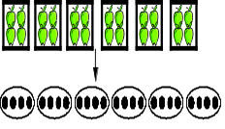 |  |  |  | Pupils use a variety of language to describe multiplication. |  |  |  | Repeated addition  5 x 3 or 3 x 5  0 3 6 9 12 15  0 5 10 15 |  |  |  |  |  |  |  |  | Arrays  6 x 4 or 4 x 6   |  |  |  |  | Recall and use multiplication facts for the 2, 5 and 10 multiplication tables, (including recognising odd and even numbers).  Use commutativity/inverse relations to develop multiplicative reasoning (eg 4 × 5 = 20 and 20 ÷ 5 = 4). | Pupils … practise to become fluent in the 2/5/10 multiplication tables and connect them to each other.  They connect the 10x table to place value, and the 5x table to divisions on the clock face.  They begin to use other multiplication tables and recall facts, including using related division facts to perform written and mental calculations.
Y3 | Write/calculate statements using the multiplication tables that they know (progressing to formal written methods).  TU x U  (multiplier is 2/3/4/5/8/10) | 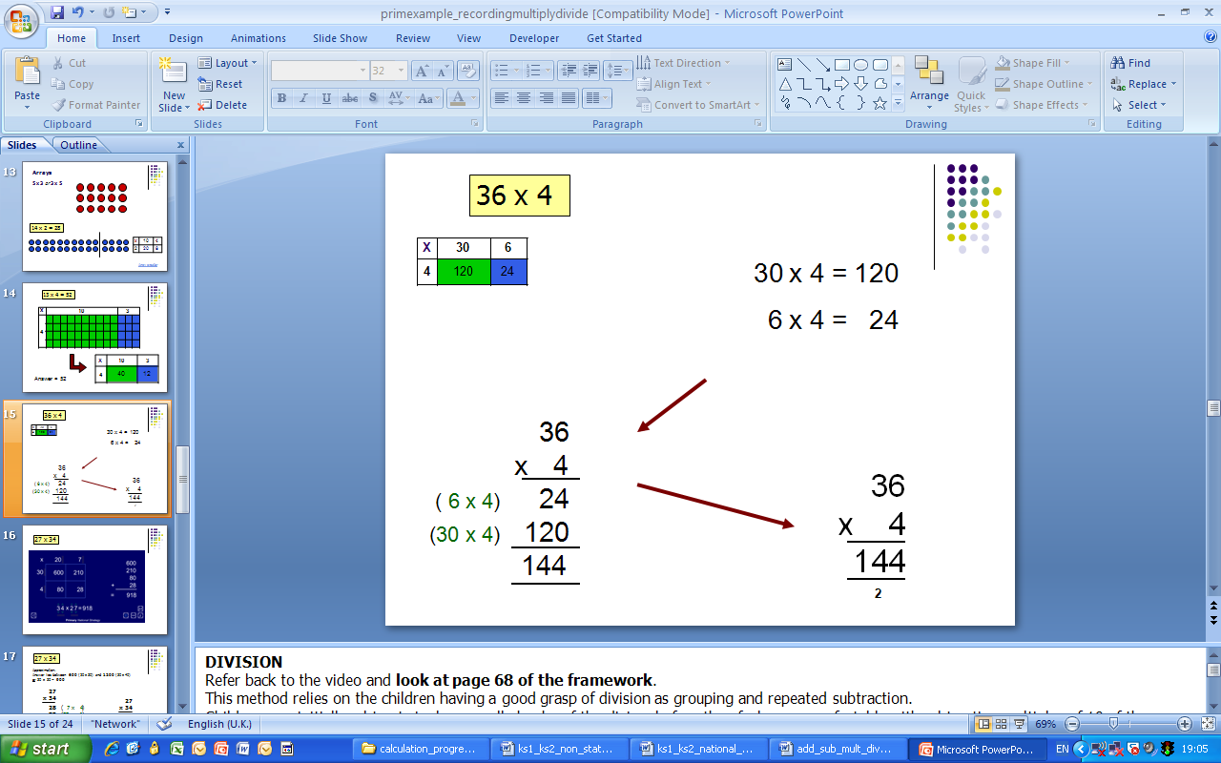  36 x 4 = 144 |  |  | 36 x 4 = 144 |  |  |  |  |  | 36 x 4 = 144 |  |  |  | 36 x 4 = 144 |  |  |  |  | Pupils develop reliable written methods for multiplication, starting with calculations of TU by U (progressing to formal written methods of short multiplication). |  |  |  | Recall and use multiplication facts for the 3, 4 and 8 multiplication tables. | Through doubling, they connect the 2/4/8 multiplication tables.  Pupils develop efficient mental methods, using commutativity (eg 4 × 12 × 5 = 4 × 5 × 12 = 20 × 12 = 240) and multiplication and division facts (eg using 3 × 2 = 6, 6 ÷ 3 = 2 & 2 = 6 ÷ 3) to derive related facts (30 × 2 = 60, 60 ÷ 3 = 20 & 20 = 60 ÷ 3).
Y4 | Use formal written layout:  TU x U  HTU x U  Convert between different units of measure [eg km to m; hr to mi] | 43 x 6 = 258  (estimate: 40 x 6 = 240)  40 x 6 = 240  3 x 6 = 18 | 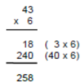  43 x 6 |  |  |  |  | 24 x 6 = 144  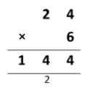 |  |  |  | 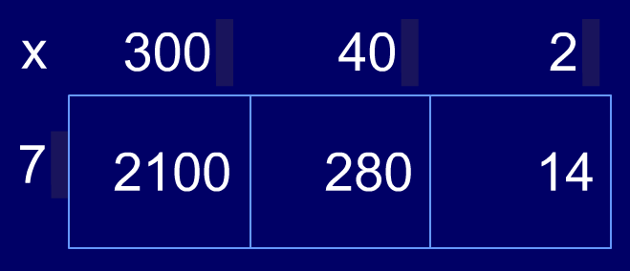  342 x 7 = 2394 |  |  |  |  |  | 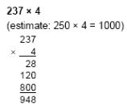 |  |  |  |  | 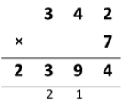  342 x 7 = 2394 | Recall multiplication facts to 12 × 12.  Use place value, known & derived facts to multiply mentally, including x by 0/1; x 3 numbers.  Recognise/use factor pairs and commutativity in mental calculations.  Pupils use multiplication to convert from larger to smaller units. | Practise mental methods and extend this to HTU numbers to derive facts, for example 200 × 3 = 600 into 600 ÷ 3 = 200.  Write statements about equality of expressions [eg 39 × 7 = 30 × 7 + 9 × 7 and (2 × 3) × 4 = 2 × (3 × 4)]. Combine knowledge of facts and arithmetic rules to solve mental/written calculations (eg 2 x 6 x 5 = 10 x 6 = 60).
Y5 | Use a formal written method (including long x for TU nos)  TU x TU  HTU x U / HTU x TU  ThHTU x U  Convert between units of measure (eg km/m; m/cm; cm/mm; kg/g; litre and ml) | 27 x 34 = 918  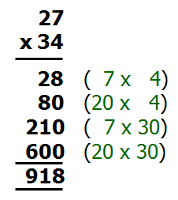  (estimate 30 x 30 = 900) |  |  |  |  |  |  | 2741 x 6 = 16446  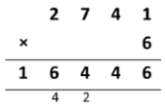  (estimate 3000 x 6 = 18000 |  |  |  | 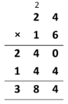  24 x 16 = 384 (estimate 25 x 15 = 375) |  |  | 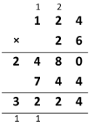  124 x 26 = 3224 |  |  |  |  | Pupils connect multiplication by a fraction to using fractions as operators (fractions of), and to division. This relates to scaling by simple fractions, including those > 1.  Find fractions of numbers and quantities, writing remainders as a fraction. |  |  | Identify multiples/factors, including finding all factor pairs of a number, & common factors of two numbers.  Know/use vocabulary of prime numbers, prime factors and composite (non-prime) nos.  Establish if a number up to 100 is prime; recall prime numbers to 19.  x nos mentally using known facts.  Multiply whole numbers and those involving decimals by 10/100/1000. | Pupils … apply all the x tables frequently, commit them to memory and use them to make larger calculations.  They understand the terms factor, multiple/prime, square/cube numbers & use to construct equiv. statements (eg 4 x 35 = 2 x 2 x 35; 3 x 270 = 3 x 3 x 9 x 10 = 9² x 10).
Y6 | Multi-digit numbers (up to 4 digits) x TU whole number using the formal method of long multiplication.  Multiply one-digit numbers with up to two decimal places by whole numbers | 256 x 18 = 4608  (estimate 250 x 20 = 5000)  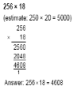 |  | 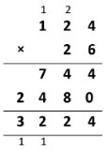  124 x 26 = 3224 |  |  |  |  |  | 4.7 x 8 = 37.6  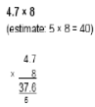  (estimate 5 x 8 = 40) [Or 47 x 8, then divide the solution by 10.] |  |  |  | Use a variety of images to support understanding of x with fractions. Use understanding of relationship between unit fractions and ÷ to work backwards by x a quantity that represents a unit fraction to find the whole quantity (eg if ¼ of a length is 36cm,whole length 36 × 4 = 144cm).  x numbers with up to 2dp by U/TU whole nos (starting with simplest cases eg 0.4 × 2 = 0.8, and in practical contexts). |  |  |  |  |  |  |  |  |  | Perform mental calculations, including with mixed operations/large numbers.  Identify common factors/multiples and prime numbers.  Use knowledge of order of operations to carry out calculations.  Use estimation to check answers to calculations and determine an appropriate degree of accuracy.  Identify value of each digit to 3dp and x nos by 10/100/1000 (ans to 3dp) | Undertake mental calcs with increasingly large numbers and more complex calculations.  Continue to use all x tables to calculate statements in order to maintain their fluency.  Explore the order of operations using brackets.  Common factors can be related to finding equivalent fractions.

DIVISION

STATUTORY EXPECTATIONS Rapid Recall/Mental Calculations Non-statutory guidance
YR | Children … solve problems, including doubling, halving and sharing. [Expected]  They solve practical problems that involve sharing into equal groups. [Exceeding] | Practical / recorded using ICT (eg digital photos/pictures on IWB) |  | Pictures/Objects  6 cakes shared between 2  6 cakes put into groups of 2   |  |  |  |  |  |  |  | Symbolic  6 cakes shared between 2 |  |  |  |  |  |  |  | There are 8 raisins.  Take half of them.  How many do you have?  Share the 10 grapes between 2 people.
Y1 | Solve one-step problems using concrete objects, pictorial representations and arrays (with the support of the teacher) | Practical/recorded using ICT  There are 14 people on the bus. Half of them get off.  How many remain on the bus?  There are 20 people in the class. One quarter are boys. How many boys are there? |  |  | Pictures/Symbolic  How many apples in each bowl if I share 12 apples between 3 bowls? |  |  |  |  |  |  | Visual (modelled using bead strings)  15 ÷ 5 = 3  0 5 10 15 |  |  |  |  |  |  |  |  |  | Recognise/find/name ½ as one of two equal parts of an object, shape or quantity.  Recognise/find/name ¼ as one of four equal parts of an object, shape or quantity. | Find simple fractions of objects, numbers and quantities  Count on/back in 2s, 5s and 10s
Y2 | Calculate statements within the multiplication tables and write them using the division and equals signs. [Show division of two numbers cannot be done in any order.]  Find ⅓, ¼, ²⁄₄, ¾ of a length/objects/quantity.  Write simple fractions eg ½ of 6 = 3 | Pictures/Symbolic  Four eggs fit in a box.  How many boxes would you need to pack 20 eggs?  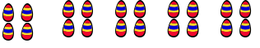   |  |  |  |  | Pupils use a variety of language to describe division. |  |  |  | Visual  (modelled using bead strings)  18 ÷ 3 = 6  0 3 6 9 12 15 18 |  |  |  |  | Arrays  Find ¼ of 24  24 ÷ 4 = 6 |  |  |  |  | Partitioning  32 ÷ 2 = 16  20 ÷ 2 = 10  12 ÷ 2 = 6 | Recall & use division facts for the 2, 5 and 10 multiplication tables,  Recognise/find/name/write fractions ⅓, ¼, ²⁄₄, ¾ of a (length, shape), set of objects or quantity.  Write simple fractions eg ½ of 6 = 3 and recognise equivalence of two quarters and one half.  Use commutativity/inverse relations to develop multiplicative reasoning (eg 4 × 5 = 20 and 20 ÷ 5 = 4). | Begin to use other multiplication tables/recall facts, including related division facts to perform written/mental calculations.  Work with materials/contexts where division relate to grouping/sharing quantities. They begin to relate these to fractions/measures (eg 40 ÷ 2 = 20, 20 is a half of 40).  They connect unit fractions to equal sharing and grouping, to numbers and to measures
Y3 | Write/calculate statements using the tables that they know (progressing to formal written methods).  TU ÷ U  (divisor is 2/3/4/5/8/10) | 96 ÷ 4 = 24  20 x 4 4 x 4  0 80 96 |  |  |  | Multiples of the divisor)  85 ÷ 5 = 17  10 x 5 = 50  7 x 5 = 35 |  |  |  | 51 ÷ 3 =17  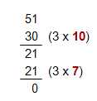 |  |  |  |  | 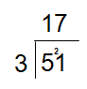  51 ÷ 3 = 17 |  |  |  |  | Pupils develop reliable written methods for division, starting with calculations of TU by U numbers (progressing to formal written methods of short division). |  | Recall and use division facts for the 3, 4 and 8 multiplication tables. | Pupils develop efficient mental methods, using commutativity (eg 4 × 12 × 5 = 4 × 5 × 12 = 20 × 12 = 240) and multiplication and division facts (eg using 3 × 2 = 6, 6 ÷ 3 = 2 & 2 = 6 ÷ 3) to derive related facts (30 × 2 = 60, 60 ÷ 3 = 20 & 20 = 60 ÷ 3).
Y4 | Pupils practise to become fluent in the formal written method of short division with exact answers [NS]  TU ÷ U; HTU ÷ U | Multiples of the divisor  98 ÷ 7 = 14  10 x 7 = 70  4 x 7 = 28 | 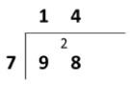  98 ÷ 7 = 14 |  |  |  |  | 252 ÷ 7 = 36  30 x 7 = 210  6 x 7 = 42 |  |  |  | 252 ÷ 7 = 36  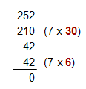 |  |  |  |  | 252 ÷ 7 = 36  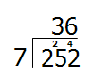 |  |  |  |  | Recall division facts to 12 × 12.  Use place value, known/derived facts to ÷ mentally, including ÷ by 1.  Find effect of dividing U/TU by 10/100, identifying the value of the digits in the answer as units/tenths/hundredths. | Practise mental methods and extend this to HTU numbers to derive facts, for example 200 × 3 = 600 into 600 ÷ 3 = 200.  Relates decimal notation to division of whole number by 10 and later 100.
Y5 | Use the formal written method of short division (interpret remainders appropriately for the context).  HTU ÷ U  ThHTU ÷ U  Convert between units of measure (eg km/m; m/cm; cm/mm; kg/g; litre and ml) | 346 ÷ 8 = 43 r2 (estimate >40, <50)  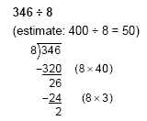 |  |  |  |  |  |  | 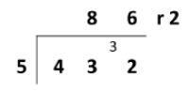  432 ÷ 5 = 86 r2  (estimate: 400 ÷ 5 = 80) |  |  |  |  | 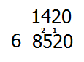  8520 ÷ 6 = 1420 |  |  |  |  | Pupils connect x by a fraction to using fractions as operators (fractions of), and to ÷. This relates to scaling by simple fractions, incl. those > 1.  Find fractions of numbers and quantities, writing remainders as a fraction. |  |  | Identify multiples/factors, including finding all factor pairs of a number, & common factors of two numbers.  Know/use vocabulary of prime numbers, prime factors and composite (non-prime) nos.  Establish if a number up to 100 is prime; recall prime numbers to 19.  ÷ nos mentally using known facts.  Divide whole numbers and those involving decimals by 10/100/1000. | Pupils … apply all the ÷ facts frequently, commit them to memory and use them to make larger calculations.  They understand the terms factor, multiple/prime, square/cube numbers & use to construct equivalent statements [eg 120 ÷15 = (30 x 4) ÷ 15 = 2 x 4 = 8]
Y6 | Divide numbers (up to 4 digits) by TU whole number using the formal method of short/long division (interpret as approp. for the context).  Use written division methods in cases where the ans has up to 2dp.  [Divide numbers up to 2dp by U/TU whole numbers.] | 43.4 ÷ 7 = 6.2  (estimate 42 ÷ 7 = 6)  6 x 7 = 42  0.2 x 7 = 1.4 |  |  | 25.6 ÷ 7 = 3.2  (estimate >3, <4)  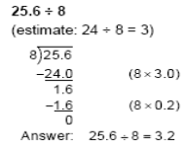 |  |  |  | 43.68 ÷ 7 = 6.24  (estimate: 42 ÷ 7 = 6)  [Or compute 4368 ÷ 7, then divide the solution by 100.]  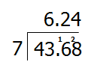 |  |  |  | 496 ÷ 11 (estimate 500 ÷ 10 = 50)  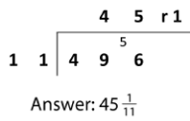 |  |  |  |  | 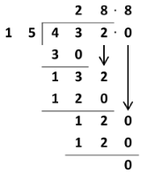  432÷ 15 = 28.8 |  |  |  | Perform mental calculations, including with mixed operations/large numbers.  Identify common factors/multiples and prime numbers.  Use knowledge of order of operations to carry out calculations.  Use estimation to check answers to calculations and determine an appropriate degree of accuracy.  Identify value of each digit to 3dp and ÷ nos by 10/100/1000 (ans to 3dp) | Undertake mental calcs with increasingly large numbers and more complex calculations.  Continue to use all table facts to calculate statements in order to maintain their fluency.  Explore the order of operations using brackets.  Common factors can be related to finding equivalent fractions.

